AUTUMN 1 | AUTUMN 2 | SPRING 1 | SPRING 2 | SUMMER 1 | SUMMER 2
BUSY BODIES   | TIME TRAVELLERS  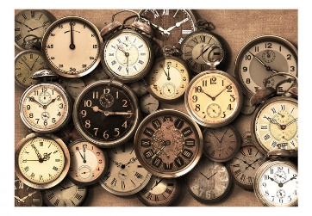 | FANTASY  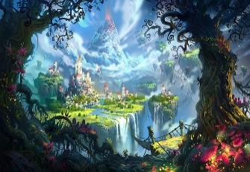 | CIRCLE OF LIFE  Survival of living things  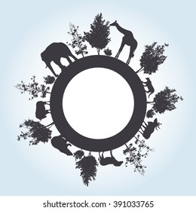 | UNDERGROUND / OVERGROUND   | HIDDEN TREASURE  (PIRATES!)  


