AUTUMN 1 | AUTUMN 2 | SPRING 1 | SPRING 2 | SUMMER 1 | SUMMER 2
PEOPLE IN MY WORLD  (PHSE fundamentally)  Families/school/community/Religion/people who help us   | CELEBRATIONS AROUND THE WORLD!  (Studying different countries as well as celebrations)  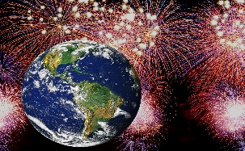 | ANIMAL KINGDOM  (Offspring/growth/native countries/ wild vs captivity /domestic pets vs working  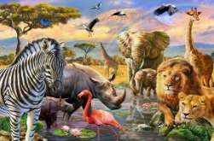 | HOW DOES YOUR GARDEN GROW?  (Life cycles and planting)  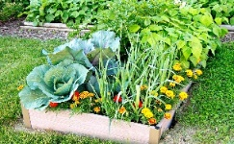 | OUTER SPACE!  (Fiction and non fiction – planets/rockets)   | WORLD OF SPORT!  (Significant sporting events – Olympics/Paralympics/ world cup etc / exercise and Health / fitness / exploring different sports)  

