Pupil premium strategy statement
This statement details our school’s use of pupil premium (and recovery premium) funding to help improve the attainment of our disadvantaged pupils.
It outlines our pupil premium strategy, how we intend to spend the funding in this academic year and the outcomes for disadvantaged pupils last academic year.

School overview
Detail | Data
Number of pupils in school | 254
Proportion (%) of pupil premium eligible pupils | 36%
Academic year/years that our current pupil premium strategy plan covers (3 year plans are recommended – you must still publish an updated statement each academic year)
Date this statement was published | 01st April 2024
Date on which it will be reviewed | 31st March 2025
Statement authorised by | Helen Willett
Pupil premium lead | Juliann Wagstaff
Governor / Trustee lead | David Mann

Funding overview
Detail | Amount
Pupil premium funding allocation this academic year | £132,113
Recovery premium funding allocation this academic year  Recovery premium received in academic year 2023/24 cannot be carried forward beyond August 31, 2024. | £65,758
Pupil premium funding carried forward from previous years (enter £0 if not applicable) | £0
Total budget for this academic year  If your school is an academy in a trust that pools this funding, state the amount available to your school this academic year | £197,870

Part A: Pupil premium strategy plan

Statement of intent
Chellow Heights School is committed to ensure that all pupils achieve well and make progress from their starting points irrespective of their needs. The focus of our pupil premium strategy is to support pupils to overcome barriers to learning so that they can achieve well.
We are working towards our goal of providing an outstanding, world class educational provision and an exciting, specialist learning environment.
At Chellow Heights we want to enable learners to be happy, healthy and enjoy life, to develop as fully as possible their self help, independence, communication and social skills to be confident and able to make decisions and achieve personal goals
Our strategy aims to have a curriculum that is holistic highly personalised and tailored to the needs of each individual child. It recognises pupils own individual learning needs and endeavours to meet their full potential both academically, socially, physically and emotionally. This approach is intended to support removing the barriers that our pupils are faced with whether they are disadvantaged or not.

Challenges
This details the key challenges to achievement that we have identified among our disadvantaged pupils.
Challenge number | Detail of challenge
1 | Reduced Sensory processing development impacts on pupil progress holistically and academically.
2 | Increased risk of pupils not being on track to meet educational outcomes sought.
3
  Risk of high rates of absence and persistent absence.
4 | The cost of living crisis has led to higher levels of social deprivation.

Intended outcomes
This explains the outcomes we are aiming for by the end of our current strategy plan, and how we will measure whether they have been achieved.
Intended outcome | Success criteria
The quality of teaching across the pathways is strong and pupils are taught by skilled and well trained staff. | There are no attainment gaps due to a pupil’s disadvantage.  Pathway CPD implemented in all classes.
Improve attendance and reduce persistent absence | Attendance closes the gap on national average (95%). Chellow is wanting 90% and above.  Attendance remains at least in line with national and their is no gap between disadvantaged and non disadvantaged. PA is significantly reduced and in line with national and disadvantaged pupils are not disproportionately represented in this category.
The highest quality of support provided for pupils. | Pupils receive the support they needs, both internally and externally, to ensure that they make strong progress from their relevant starting points.
Social deprivation does not negatively impact on pupil attendance, attainment or accessing extra curricular (lunch time / after school clubs) and enrichment opportunities. | There is no gap between disadvantaged and non disadvantaged pupils attendance and it is at least in line with national average.  There is an increase in disadvantaged pupils accessing extra curricular and enrichment activities. provision.
Interventions (academic and holistic) are swiftly introduced and are effective in ensuring pupils meet the educational outcomes sought. | % of behaviour incidents for disadvantaged pupils will not be over represented in the behaviour logs.  Progress information for disadvantaged groups is in line with non disadvantaged groups.

Activity in this academic year
This details how we intend to spend our pupil premium (and recovery premium) funding this academic year to address the challenges listed above.Teaching (for example, CPD, recruitment and retention)
Budgeted cost: £45,699
Activity | Evidence that supports this approach | Challenge number(s) addressed
CPD Scheme- Pathway Training | Training delivered, monitoring, feedback sheets.  EEF blog: Understanding the relationship between implementation… | EEF (educationendowmentfoundation.org.uk) | 1,2
Recruitment of highly effective teachers / SNTAs | Interviews, high standard and quality of teaching improved.  Making Best Use of Teaching Assistants | EEF (educationendowmentfoundation.org.uk) | 1,2
Home visits and attendance meetings | Regular meeting with parents and professionals. | 3
Reflective Teaching | Teachers reflecting on their practice. Monitoring and feedback in place. | 1,2
Curriculum TLRs | Curriculum imbedded. Monitored in line with the delivery of lesson and assessment. | 1,2
Highly skilled HLTA employed with a focus on improving | Interviews, high standard and quality of teaching improved.  Making Best Use of Teaching Assistants | EEF (educationendowmentfoundation.org.uk) | 1,2
Sensory processing training | Whole school training delivered, monitoring and feedback. Materials orders to support. | 1,2

Targeted academic support (for example, tutoring, one-to-one support, structured interventions)
Budgeted cost: £50,494
Activity | Evidence that supports this approach | Challenge number(s) addressed
Internal/External holistic interventions - Horse riding | 2 sessions weekly. | 1,2,4
Internal/External holistic interventions - Holms dance | 1 session weekly | 1,2,4
Internal/External holistic interventions - Music therapy | 1:1 sessions | 1,2,4
After school club provision | Weekly session offered. | 3,4
Internal/External holistic interventions - Move program | Weekly sessions. Small groups, 1:1 sessions.  Move built into the class timetables. | 1,2,4
Internal/External holistic interventions - Lets Listen and Move | Weekly sessions. Small groups, 1:1 sessions.  Move built into the class timetables. | 1,2,4
Internal/External holistic interventions - Flamingo Chick | Weekly sessions, held on both sites | 1,2,4
Internal/External holistic interventions – Hydrotherapy | Weekly sessions in school | 1,2,4
Internal/External holistic interventions - | 2 sessions a week | 1,2,4
Opportunities to attend residentials | 2 residentials offered to all Year 6 pupils. | 4
School uniforms provided | School uniforms ordered. | 4
Breakfast club | Built into timetable. | 4

Wider strategies (for example, related to attendance, behaviour, wellbeing)
Budgeted cost: £49,000
Activity | Evidence that supports this approach | Challenge number(s) addressed
Contribution to cultural capital extra curricular and enrichment programme. | https://educationendowmentfoundation.org.uk/guidance-for-teachers/life-skills-enrichment | 1,2,3,4
New Minibuses – extra curriculum trips | There is an increase in disadvantaged pupils accessing extra curricular and enrichment activities provision. | 1, 2,3,4

Total budgeted cost: £145,193

Part B: Review of the previous academic year

Outcomes for disadvantaged pupils
This details the impact that our pupil premium activity had on pupils in the 2022 - 2023 academic year. Data from September 2022 – September 2023. BSquared was a new assessment system that had been introduced at school. Not all PP pupil were identified on the system so data is inconclusive. Overall, pupil progress was good.
Engagement – 14 pupils working Engagement steps. All pupils making progress within the 4 key areas of learning.

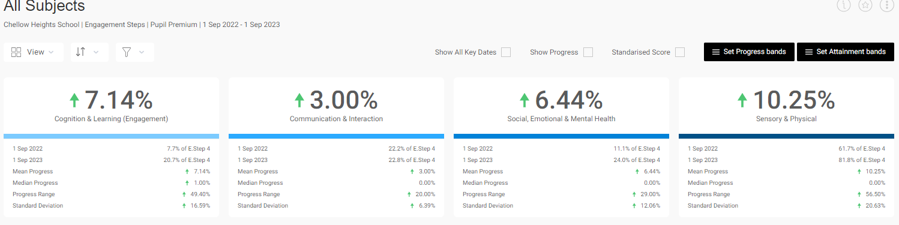

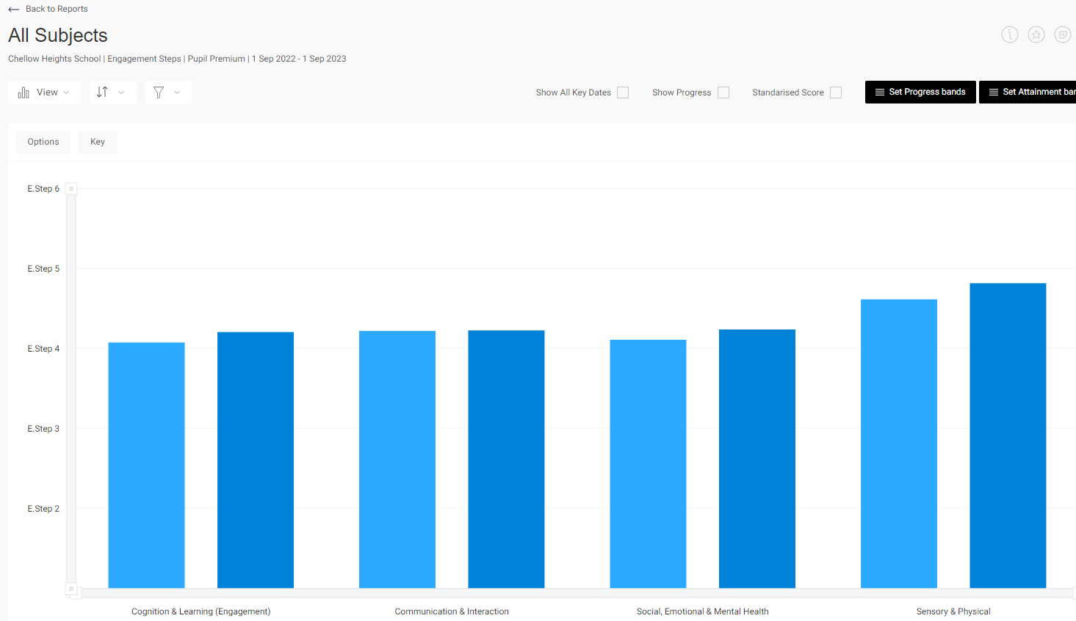

Progression – 8 pupils working on Progression steps. All pupils making progress within the 3 key areas of learning.
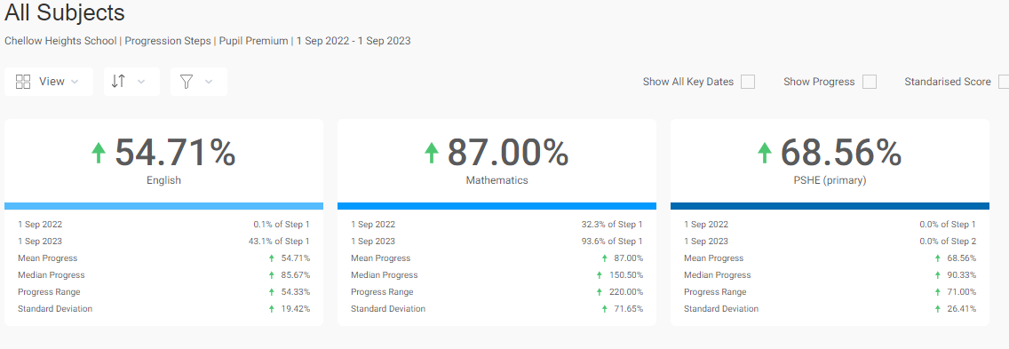
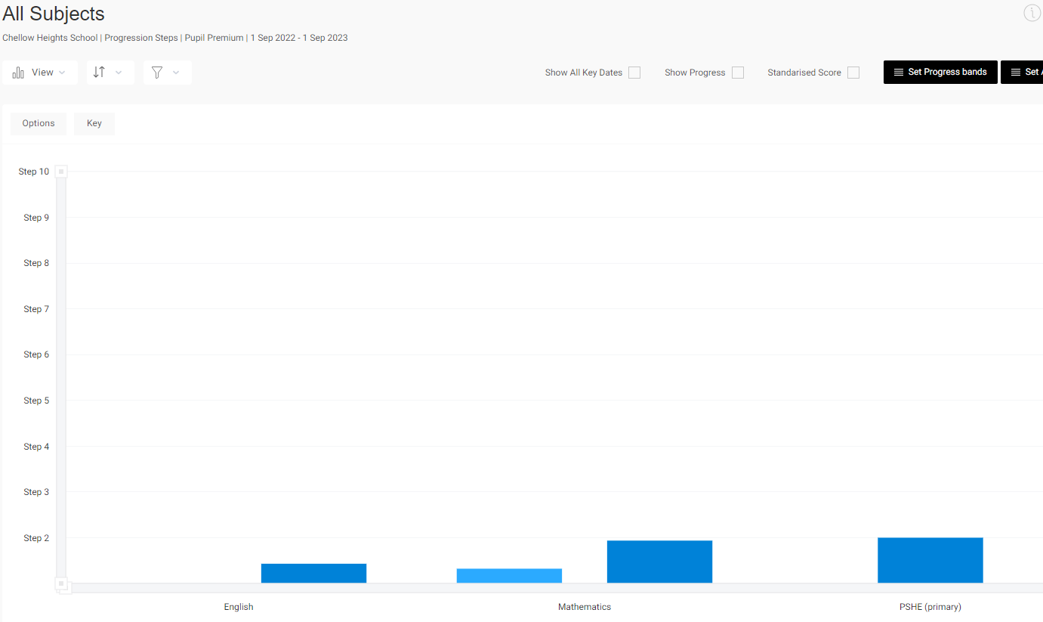

Externally provided programmes
Please include the names of any non-DfE programmes that you used your pupil premium (or recovery premium) to fund in the previous academic year.
Programme | Provider

Service pupil premium funding (optional)
For schools that receive this funding, you may wish to provide the following information: How our service pupil premium allocation was spent last academic year
The impact of that spending on service pupil premium eligible pupils

Further information (optional)
Use this space to provide any further information about your pupil premium strategy. For example, about your strategy planning, implementation and evaluation, or other activity that you are delivering to support disadvantaged pupils, that is not dependent on pupil premium or recovery premium funding.

